**How to Install Kubernetes Cluster on Ubuntu 24.04 LTS (Step-by-Step Guide)**

Kubernetes is a powerful container orchestration platform used for automating the deployment, scaling, and management of containerized applications. In this guide, we will walk you through the step-by-step process of installing Kubernetes on Ubuntu 22.04. This cluster configuration includes a master node and worker nodes, allowing you to harness the full power of Kubernetes.

**Kubernetes Nodes**

In a Kubernetes cluster, you will encounter two distinct categories of nodes:

**Master Nodes:** These nodes play a crucial role in managing the control API calls for various components within the Kubernetes cluster. This includes overseeing pods, replication controllers, services, nodes, and more.

**Worker Nodes:** Worker nodes are responsible for providing runtime environments for containers. It’s worth noting that a group of container pods can extend across multiple worker nodes, ensuring optimal resource allocation and management.

**Prerequisites**

Before diving into the installation, ensure that your environment meets the following prerequisites:

* An Ubuntu 24.04 LTS system.
* Privileged access to the system (root or sudo user).
* Active internet connection.
* Minimum 2GB RAM or more.
* Minimum 2 CPU cores (or 2 vCPUs).
* 20 GB of free disk space on /var (or more).

**Step 1: Update and Upgrade Ubuntu (all nodes)**

Begin by ensuring that your system is up to date. Open a terminal and execute the following commands:

sudo apt update && sudo apt upgrade -y

**Step 2: Disable Swap (all nodes)**

To enhance Kubernetes performance, disable swap and set essential kernel parameters. Run the following commands on all nodes to disable all swaps:

sudo swapoff -a  
sudo sed -i '/ swap / s/^\(.*\)$/#\1/g' /etc/fstab

**Step 3: Add Kernel Parameters (all nodes)**

Load the required kernel modules on all nodes:

sudo tee /etc/modules-load.d/containerd.conf <<EOF  
overlay  
br_netfilter  
EOF  
sudo modprobe overlay  
sudo modprobe br_netfilter

Configure the critical kernel parameters for Kubernetes using the following:

sudo tee /etc/sysctl.d/kubernetes.conf <<EOF  
net.bridge.bridge-nf-call-ip6tables = 1  
net.bridge.bridge-nf-call-iptables = 1  
net.ipv4.ip_forward = 1  
EOF

Then, reload the changes:

sudo sysctl --system

**Step 4: Install Containerd Runtime (all nodes)**

We are using the containerd runtime. Install containerd and its dependencies with the following commands:

sudo apt install -y curl gnupg2 software-properties-common apt-transport-https ca-certificates

Enable the Docker repository:

sudo curl -fsSL https://download.docker.com/linux/ubuntu/gpg | sudo gpg --dearmour -o /etc/apt/trusted.gpg.d/docker.gpg  
sudo add-apt-repository "deb [arch=amd64] https://download.docker.com/linux/ubuntu $(lsb_release -cs) stable"

Update the package list and install containerd:

sudo mkdir /etc/containerd

sudo apt update  
sudo apt install -y containerd.io

Configure containerd to start using systemd as cgroup:

containerd config default | sudo tee /etc/containerd/config.toml >/dev/null 2>&1  
sudo sed -i 's/SystemdCgroup \= false/SystemdCgroup \= true/g' /etc/containerd/config.toml

Restart and enable the containerd service:

sudo systemctl restart containerd  
sudo systemctl enable containerd

**Step 5: Add Apt Repository for Kubernetes (all nodes)**

Kubernetes packages are not available in the default Ubuntu 22.04 repositories. Add the Kubernetes repositories with the following commands:

echo "deb [signed-by=/etc/apt/keyrings/kubernetes-apt-keyring.gpg] https://pkgs.k8s.io/core:/stable:/v1.30/deb/ /" | sudo tee /etc/apt/sources.list.d/kubernetes.list  
curl -fsSL https://pkgs.k8s.io/core:/stable:/v1.30/deb/Release.key | sudo gpg --dearmor -o /etc/apt/keyrings/kubernetes-apt-keyring.gpg

**Step 6: Install Kubectl, Kubeadm, and Kubelet (all nodes)**

After adding the repositories, install essential Kubernetes components, including kubectl, kubelet, and kubeadm, on all nodes with the following commands:

sudo apt update  
sudo apt install -y kubelet kubeadm kubectl  
sudo apt-mark hold kubelet kubeadm kubectl

**Step 7: Initialize Kubernetes Cluster with Kubeadm (master node)**

With all the prerequisites in place, initialize the Kubernetes cluster on the master node using the following Kubeadm command:

sudo kubeadm init

root@master:~# sudo kubeadm init  
[init] Using Kubernetes version: v1.30.3  
[preflight] Running pre-flight checks  
[preflight] Pulling images required for setting up a Kubernetes cluster  
[preflight] This might take a minute or two, depending on the speed of your internet connection  
[preflight] You can also perform this action in beforehand using 'kubeadm config images pull'  
W0810 16:57:59.292992 15792 checks.go:844] detected that the sandbox image "registry.k8s.io/pause:3.8" of the container runtime is inconsistent with that used by kubeadm.It is recommended to use "registry.k8s.io/pause:3.9" as the CRI sandbox image.  
[certs] Using certificateDir folder "/etc/kubernetes/pki"  
[certs] Generating "ca" certificate and key  
[certs] Generating "apiserver" certificate and key  
[certs] apiserver serving cert is signed for DNS names [kubernetes kubernetes.default kubernetes.default.svc kubernetes.default.svc.cluster.local master] and IPs [10.96.0.1 138.197.184.45]  
[certs] Generating "apiserver-kubelet-client" certificate and key  
[certs] Generating "front-proxy-ca" certificate and key  
[certs] Generating "front-proxy-client" certificate and key  
[certs] Generating "etcd/ca" certificate and key  
[certs] Generating "etcd/server" certificate and key  
[certs] etcd/server serving cert is signed for DNS names [localhost master] and IPs [138.197.184.45 127.0.0.1 ::1]  
[certs] Generating "etcd/peer" certificate and key  
[certs] etcd/peer serving cert is signed for DNS names [localhost master] and IPs [138.197.184.45 127.0.0.1 ::1]  
[certs] Generating "etcd/healthcheck-client" certificate and key  
[certs] Generating "apiserver-etcd-client" certificate and key  
[certs] Generating "sa" key and public key  
[kubeconfig] Using kubeconfig folder "/etc/kubernetes"  
[kubeconfig] Writing "admin.conf" kubeconfig file  
[kubeconfig] Writing "super-admin.conf" kubeconfig file  
[kubeconfig] Writing "kubelet.conf" kubeconfig file  
[kubeconfig] Writing "controller-manager.conf" kubeconfig file  
[kubeconfig] Writing "scheduler.conf" kubeconfig file  
[etcd] Creating static Pod manifest for local etcd in "/etc/kubernetes/manifests"  
[control-plane] Using manifest folder "/etc/kubernetes/manifests"  
[control-plane] Creating static Pod manifest for "kube-apiserver"  
[control-plane] Creating static Pod manifest for "kube-controller-manager"  
[control-plane] Creating static Pod manifest for "kube-scheduler"  
[kubelet-start] Writing kubelet environment file with flags to file "/var/lib/kubelet/kubeadm-flags.env"  
[kubelet-start] Writing kubelet configuration to file "/var/lib/kubelet/config.yaml"  
[kubelet-start] Starting the kubelet  
[wait-control-plane] Waiting for the kubelet to boot up the control plane as static Pods from directory "/etc/kubernetes/manifests"  
[kubelet-check] Waiting for a healthy kubelet. This can take up to 4m0s  
[kubelet-check] The kubelet is healthy after 1.004099735s  
[api-check] Waiting for a healthy API server. This can take up to 4m0s  
[api-check] The API server is healthy after 6.502017982s  
[upload-config] Storing the configuration used in ConfigMap "kubeadm-config" in the "kube-system" Namespace  
[kubelet] Creating a ConfigMap "kubelet-config" in namespace kube-system with the configuration for the kubelets in the cluster  
[upload-certs] Skipping phase. Please see --upload-certs  
[mark-control-plane] Marking the node master as control-plane by adding the labels: [node-role.kubernetes.io/control-plane node.kubernetes.io/exclude-from-external-load-balancers]  
[mark-control-plane] Marking the node master as control-plane by adding the taints [node-role.kubernetes.io/control-plane:NoSchedule]  
[bootstrap-token] Using token: 72ww2b.6orffywqcf5s4p2z  
[bootstrap-token] Configuring bootstrap tokens, cluster-info ConfigMap, RBAC Roles  
[bootstrap-token] Configured RBAC rules to allow Node Bootstrap tokens to get nodes  
[bootstrap-token] Configured RBAC rules to allow Node Bootstrap tokens to post CSRs in order for nodes to get long term certificate credentials  
[bootstrap-token] Configured RBAC rules to allow the csrapprover controller automatically approve CSRs from a Node Bootstrap Token  
[bootstrap-token] Configured RBAC rules to allow certificate rotation for all node client certificates in the cluster  
[bootstrap-token] Creating the "cluster-info" ConfigMap in the "kube-public" namespace  
[kubelet-finalize] Updating "/etc/kubernetes/kubelet.conf" to point to a rotatable kubelet client certificate and key  
[addons] Applied essential addon: CoreDNS  
[addons] Applied essential addon: kube-proxy  
  
Your Kubernetes control-plane has initialized successfully!  
  
To start using your cluster, you need to run the following as a regular user:  
  
 mkdir -p $HOME/.kube  
 sudo cp -i /etc/kubernetes/admin.conf $HOME/.kube/config  
 sudo chown $(id -u):$(id -g) $HOME/.kube/config  
  
Alternatively, if you are the root user, you can run:  
  
 export KUBECONFIG=/etc/kubernetes/admin.conf  
  
You should now deploy a pod network to the cluster.  
Run "kubectl apply -f [podnetwork].yaml" with one of the options listed at:  
 https://kubernetes.io/docs/concepts/cluster-administration/addons/  
  
Then you can join any number of worker nodes by running the following on each as root:  
  
kubeadm join 138.197.184.45:6443 --token 72ww2b.6orffywqcf5s4p2z \  
 --discovery-token-ca-cert-hash sha256:aafb79cdd45a6e3b3fac01fb3efba0817360b01f90a4b6c3f11567108a36ba67   
root@master:~# mkdir -p $HOME/.kube  
 sudo cp -i /etc/kubernetes/admin.conf $HOME/.kube/config  
 sudo chown $(id -u):$(id -g) $HOME/.kube/config

After the initialization is complete make a note of the kubeadm joincommand for future reference.

Run the following commands on the master node:

mkdir -p $HOME/.kube  
sudo cp -i /etc/kubernetes/admin.conf $HOME/.kube/config  
sudo chown $(id -u):$(id -g) $HOME/.kube/config

Next, use kubectl commands to check the cluster and node status:

kubectl get nodes

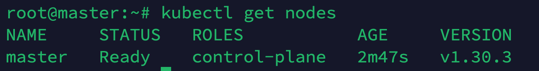

**Step 8: Add Worker Nodes to the Cluster (worker nodes)**

On each worker node, use the kubeadm join command you noted down earlier:

kubeadm join 138.197.184.45:6443 --token 72ww2b.6orffywqcf5s4p2z \  
 --discovery-token-ca-cert-hash sha256:aafb79cdd45a6e3b3fac01fb3efba0817360b01f90a4b6c3f11567108a36ba67

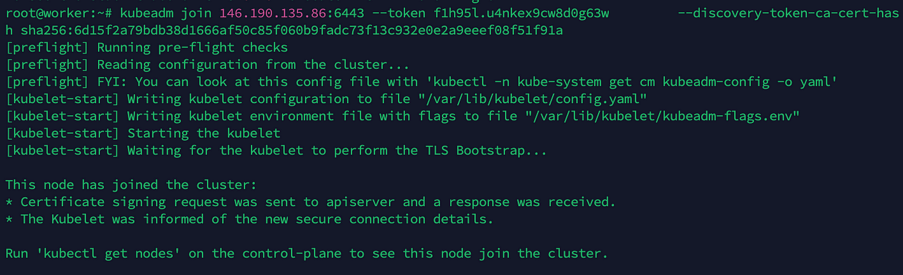

**Step :9 Install Kubernetes Network Plugin (master node)**

To enable communication between pods in the cluster, you need a network plugin. Install the Calico network plugin with the following command from the master node:

kubectl apply -f https://raw.githubusercontent.com/projectcalico/calico/v3.25.0/manifests/calico.yaml

**Step 10: Verify the cluster and test (master node)**

Finally, we want to verify whether our cluster is successfully created.

kubectl get pods -n kube-system  
kubectl get nodes

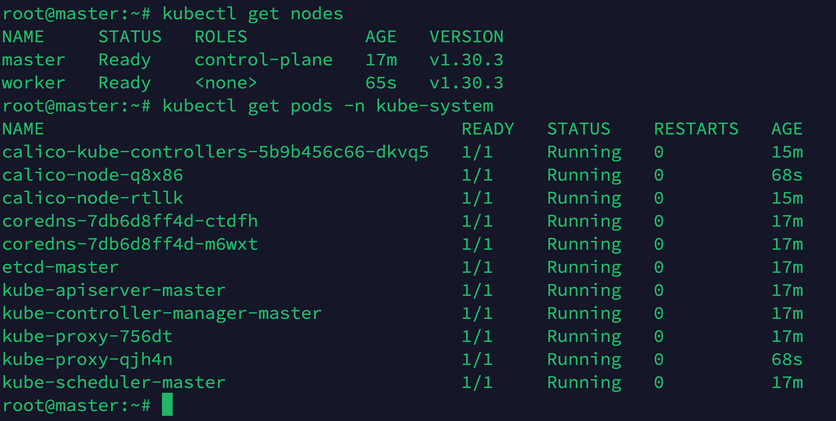

**Step 11: Deploy test application on cluster (master node)**

kubectl run nginx --image=nginx

